Publishing Reports on Tomcat

This section will guide you to:

* Integrate Automation framework in Tomcat and publish Reports.

**Development Environment**

* Eclipse IDE for Enterprise Java Developers Version Oxygen.3a Release (4.7.3a)
* JavaDevelopment Kit Version 8
* Tomcat server/9.0.26 (https://localhost:8080)

This guide has only four sub-sections, namely:

1.6.1 Starting Tomcat server

1.6.2 Creating war file from Eclipse

1.6.3 Publishing report on Tomcat

1.6.4 Pushing the code to your GitHub repositories

**Step 1.6.1:** Starting Tomcat server

* Download Tomcat within Eclipse using the following steps:
  + Open your eclipse environment from the desktop.
  + Select File tab, click on New>Other.
  + In the next page, click on Server from the server folder drop down. Click on Next.
  + Type tomcat in the filter text field. Select the tomcat version that you would like to install and click on Next.
  + Click on Download and Install. Select the directory where you want to download tomcat. Select the installed JRE and click Finish.
* Start the tomcat server in Eclipse

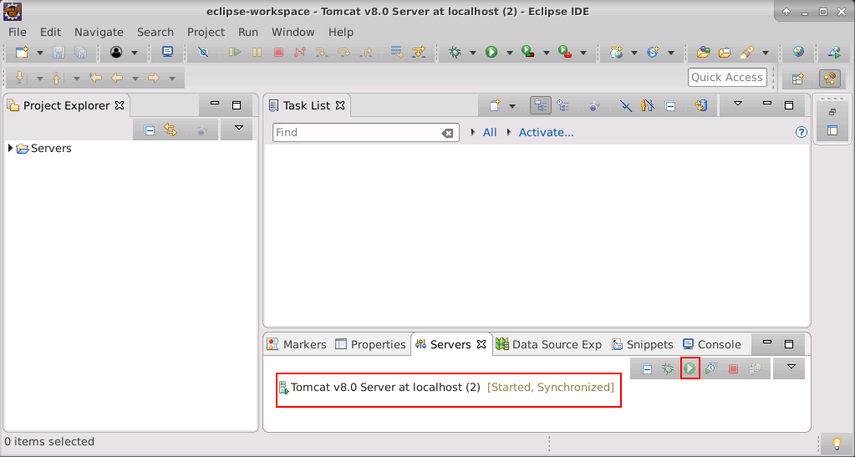

**Step 1.6.2:** Creating WAR file from Eclipse.

* Open Eclipse.
* Right-click on Project.
* Click on Export.
* Click on the Web in the Export window.
* Select WAR file and click on Next button.
* Enter the destination where the WAR file has to be saved.
* Check the ‘Export source file’ and ‘Overwrite Existing file’ checkboxes.

**Step 1.6.3:** Publishing Report on Tomcat

* Open the browser.
* Enter the url: <https://localhost:8090> and click on Enter.
* Click on the Manager App button.

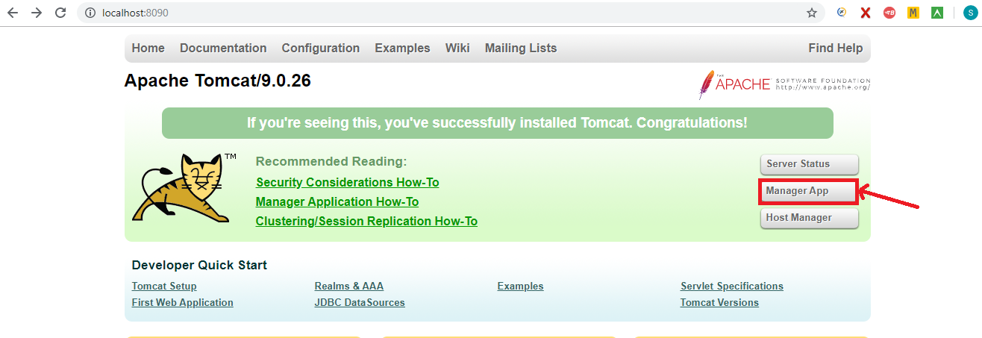

* Move to ‘WAR file to deploy’ block and click on “Choose” file.

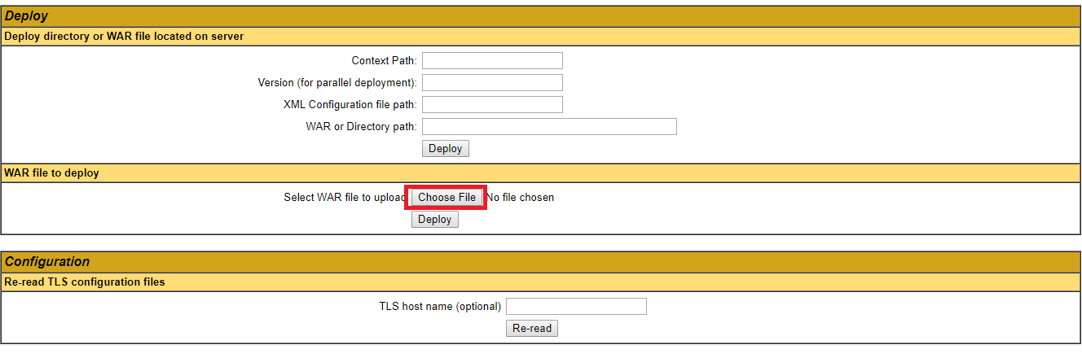

* Select the WAR file which we have created from Eclipse.
* Click on the ‘Deploy’ button.
* The filename will be displayed in applications list in Tomcat home page and will look like

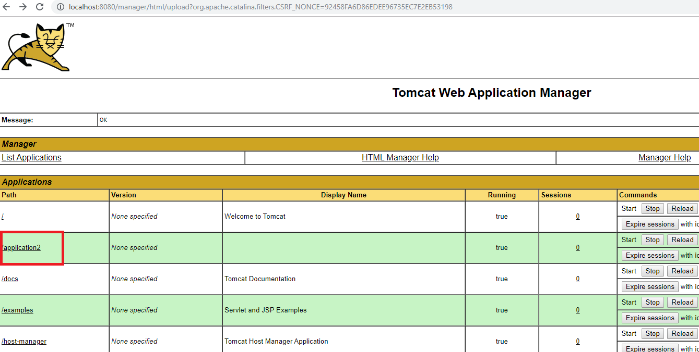

* Click on the file name which we have deployed.
* The report is displayed in the Tomcat(output), which will look like

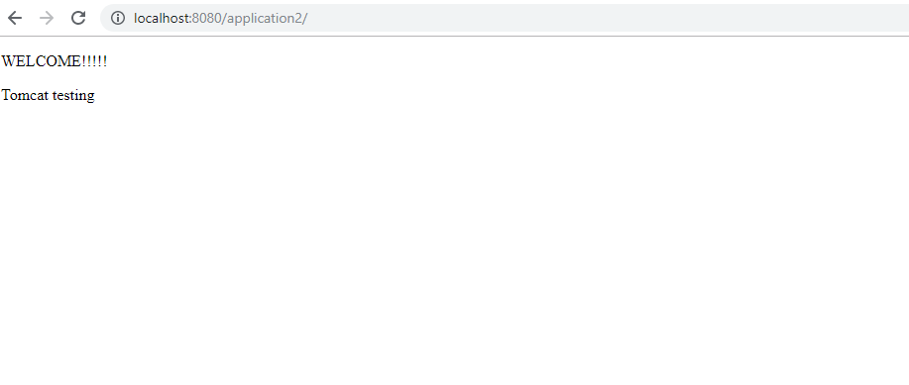

**Step 1.6.4:** Pushing the code to your GitHub repositories

Open your command prompt and navigate to the folder where you have created your files.

cd <folder path>

Initialize your repository using the following command:

git init

Add all the files to your git repository using the following command:

git add .

Commit the changes using the following command:

git commit . -m “Changes have been committed.”

Push the files to the folder you initially created using the following command:

git push -u origin master